S-Louvers

Orientation

Grade

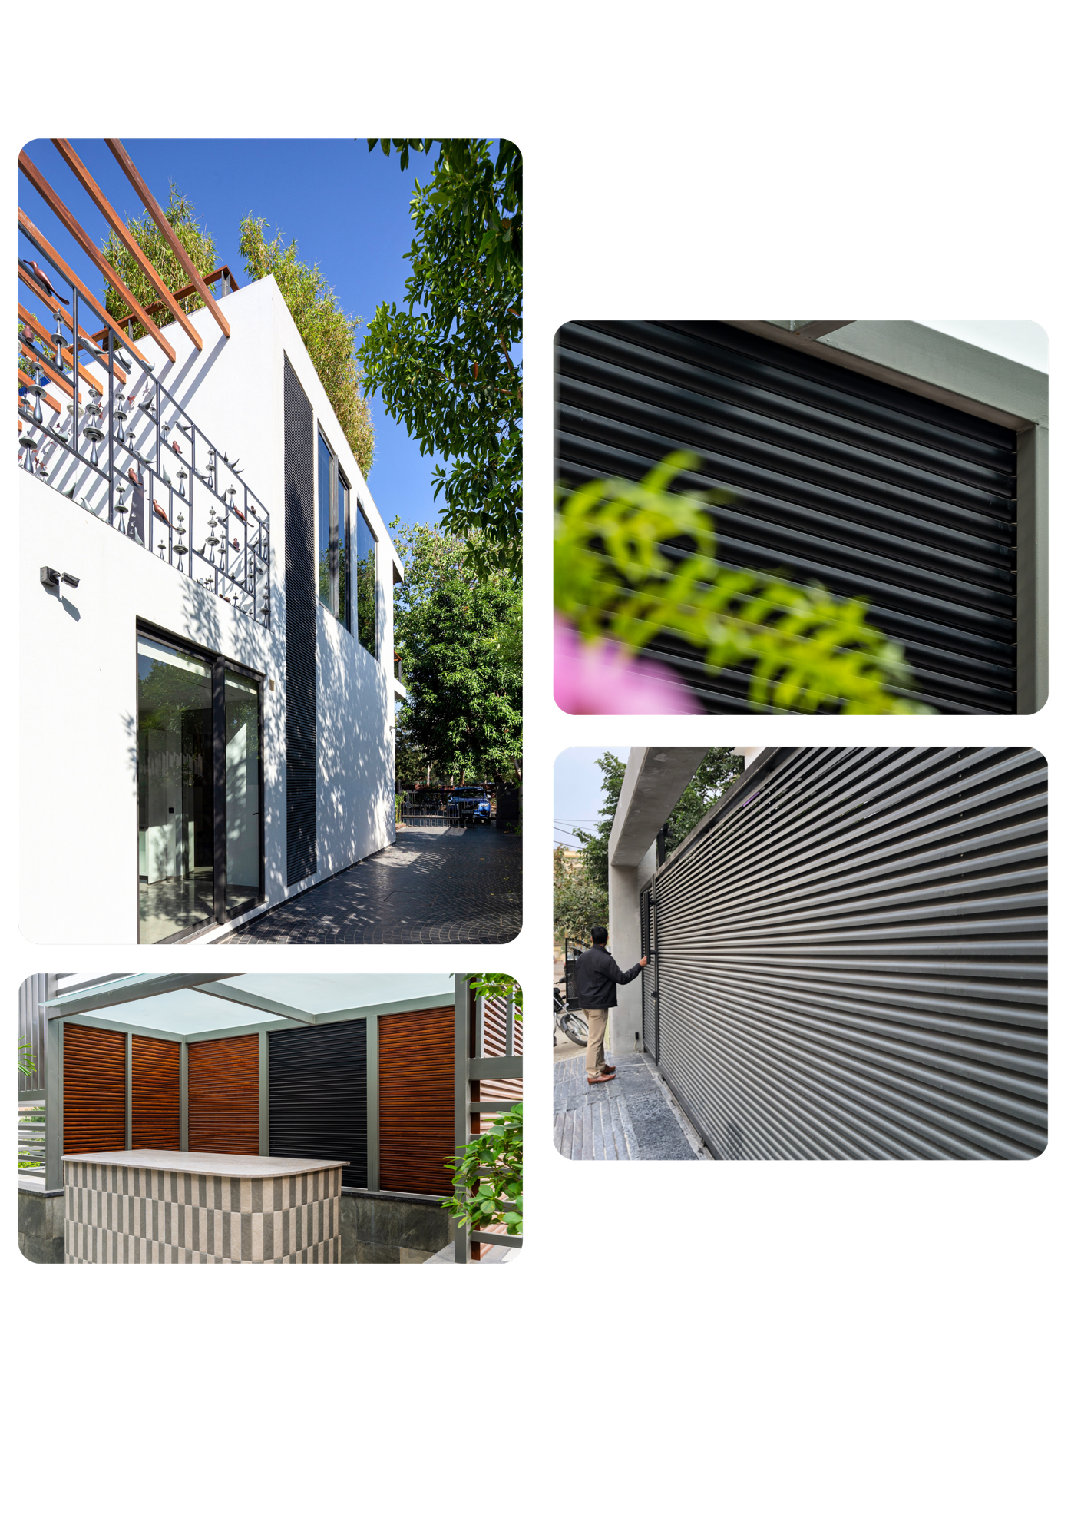

«Orientation»

Aluminum Alloy

6063 T6

«Finish»

Finish

Color Coverage

«Coverage»